Interactive Web Design:

Element 011

By P110076169

23rd December 2022



# Contents

**Contents** **2**

**Site Map** **4**

Site Map Draft 4

Site Map Final Design 4

**Wireframe/Low Fidelity** **5**

Wireframe - Home Page 5

Wireframe - About Page 6

Wireframe - Blog Post Listing Page 7

Wireframe - Blog Post Page 8

Wireframe - Contact Page 9

Wireframe - Concept of Menu Idea 9

Wireframe - Recipe Listing Page 11

Wireframe - Recipe Page 12

Low Fidelity - Overview 13

Low Fidelity - Home Page 14

Low Fidelity - Mobile Menu Demonstration 14

Low Fidelity - About Page 15

Low Fidelity - Blog Listing Page 15

Low Fidelity - Blog Post Page 16

Low Fidelity - Recipe Listing Page 16

Low Fidelity - Recipe Page 17

Low Fidelity - Contact Page 17

**Logo Design** **18**

Logo Design Draft Ideas 18

Final Logo Designed in Illustrator 19

Logo as a Favicon 20

Design as Favicon In Tab 20

Design Ready to Made into a Progressive Web App with multiple Sizings and a Maskable Icon 21

**Mid Fidelity** **21**

Mid Fidelity - Overview 22

Mid Fidelity - Home Page 23

Mid Fidelity - Mobile Menu Demonstration 23

Mid Fidelity - About Page 24

Mid Fidelity - Blog Listing Page 24

Mid Fidelity - Blog Post Page 25

Mid Fidelity - Recipe Listing Page 25

Mid Fidelity - Recipe Page 26

Mid Fidelity - Contact Page 26

**Testing** **26**

Get Baking Test Suite Overview 27

Navbar Navigation Test 27

Home Random Recipe Test 28

Footer Social Media Test 28

Footer Navigation Test 28

Home Blog Links Test 29

Footer Hidden Link Test 29

Home Our Aim Test 29

Sidebar Navigation Test 29

Home Seasonal Recipe Test 30

Blog List Link Test 30

Home Popular Recipe Test 30

Blog Page Component Verify Test 31

Recipe List Link Test 31

Blog Page Related Link Test 31

Recipe Page Interactivity Test 32

Recipe Page PDF Test 32

Recipe Page Present Component Test 32

Recipe Page Related Recipe Test 33

Recipe Page Social Media Test 33

About Page Link Verify Test 33

About Page Verify Components Test 34

Contact Form Interactivity Test 34

# Site Map

## Site Map Draft

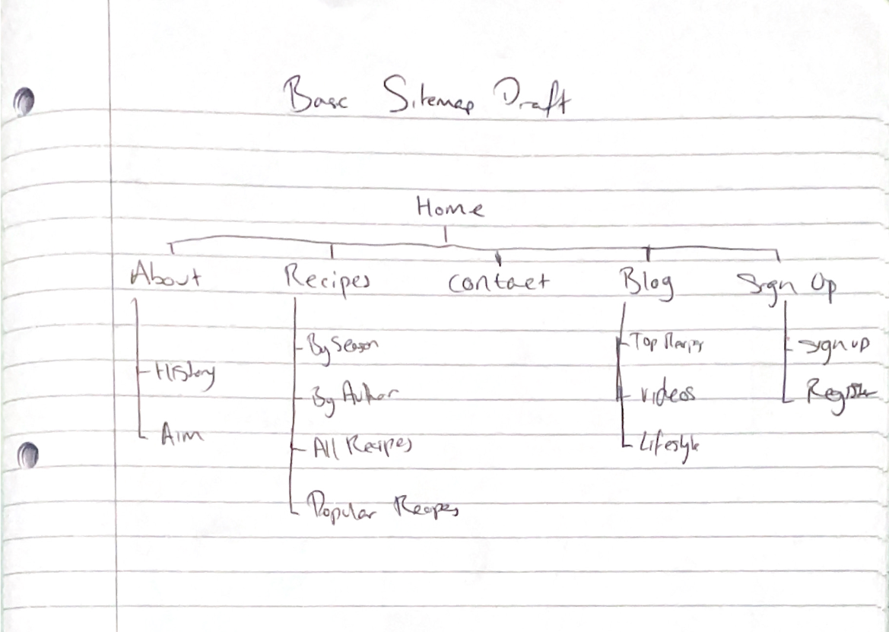

## Site Map Final Design

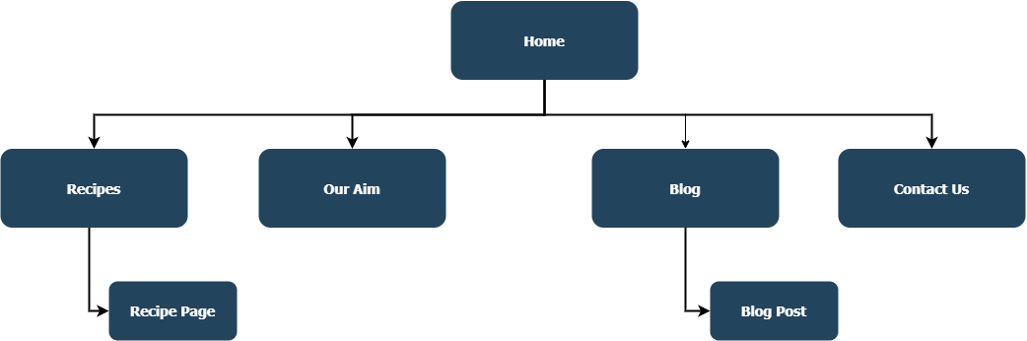

# Wireframe/Low Fidelity

## Wireframe - Home Page

# 

## Wireframe - About Page

# 

# 

## Wireframe - Blog Post Listing Page

## 

## Wireframe - Blog Post Page

## 

## Wireframe - Contact Page

## 

## Wireframe - Concept of Menu Idea

## Wireframe - Recipe Listing Page

## 

## Wireframe - Recipe Page

## 

## Low Fidelity - Overview

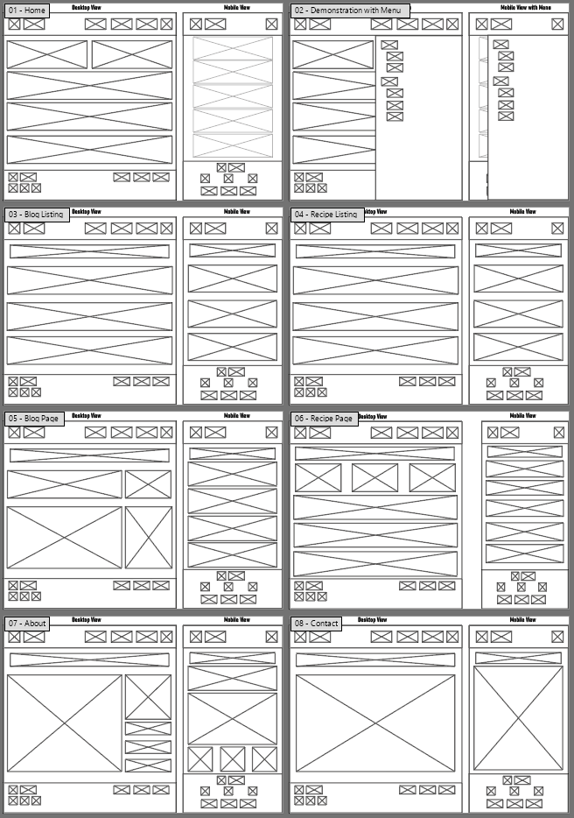

## Low Fidelity - Home Page

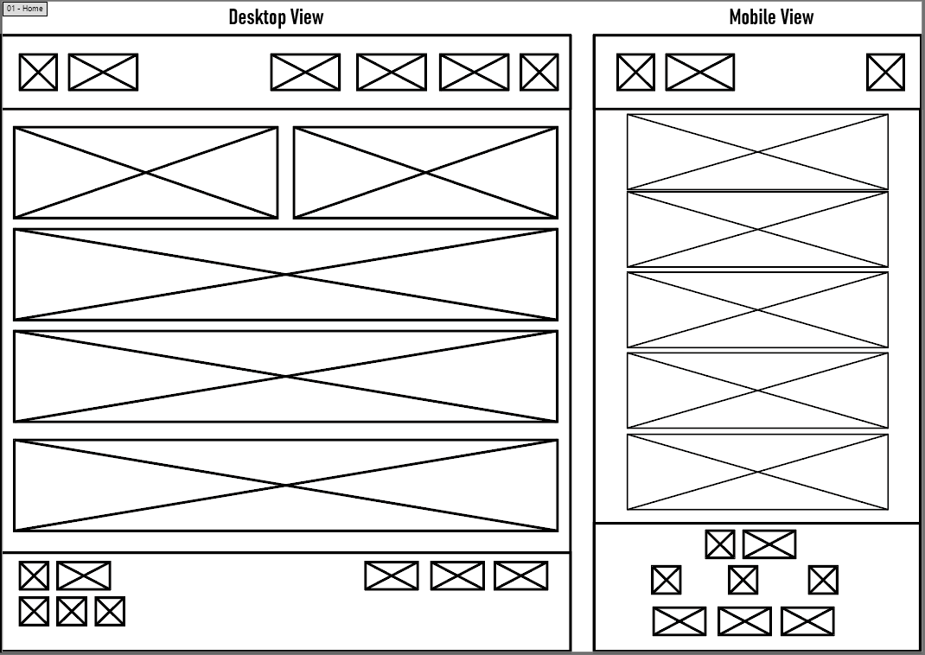

## Low Fidelity - Mobile Menu Demonstration

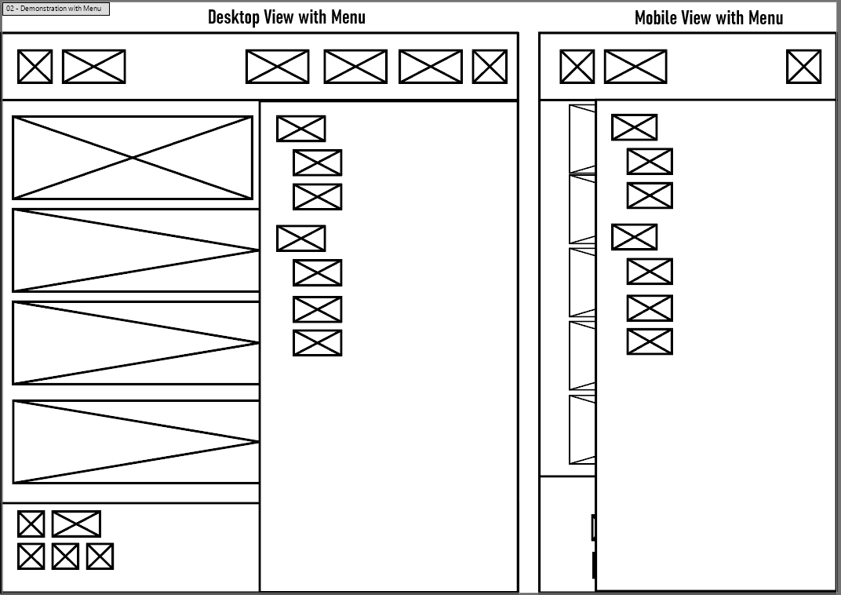

## Low Fidelity - About Page

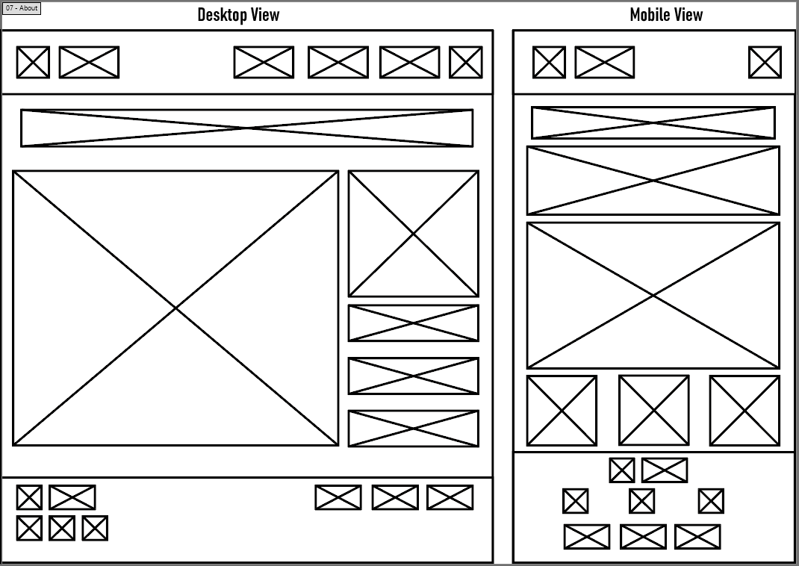

## Low Fidelity - Blog Listing Page

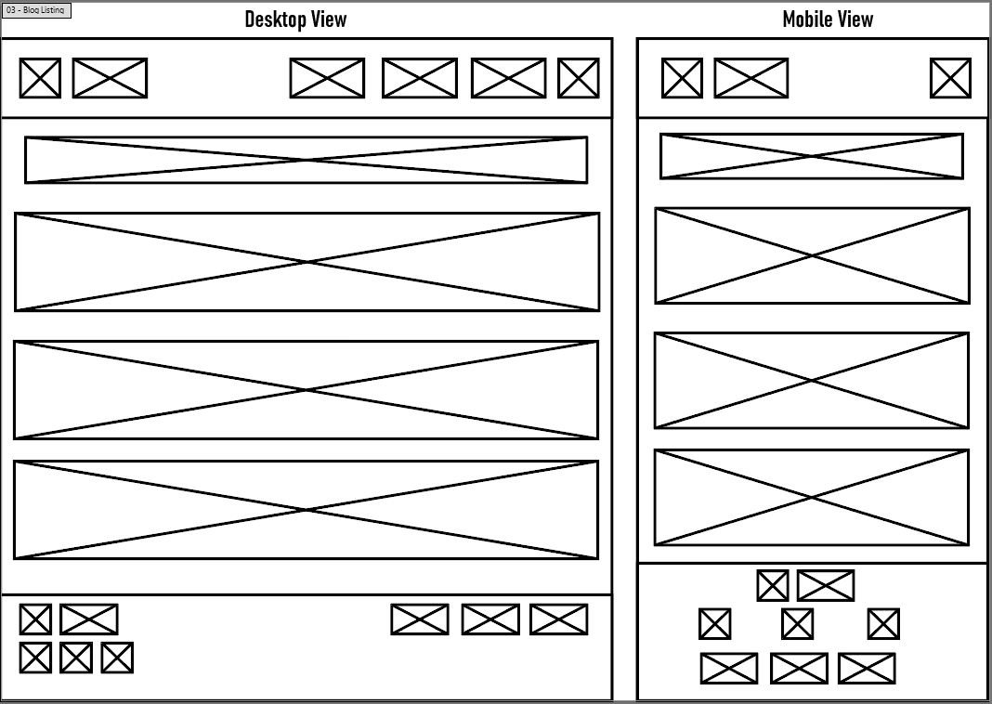

## Low Fidelity - Blog Post Page

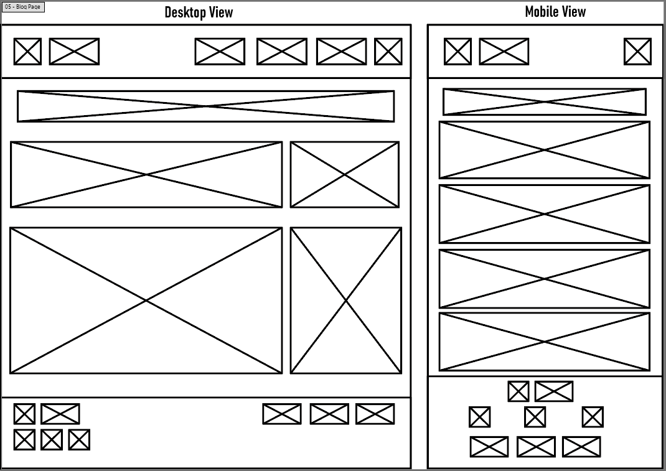

## Low Fidelity - Recipe Listing Page

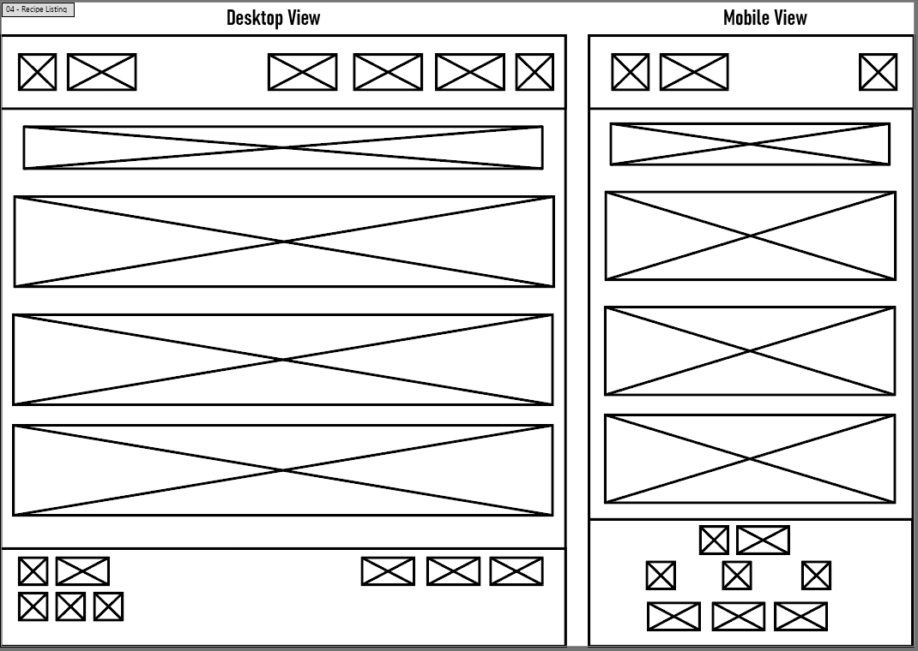

## Low Fidelity - Recipe Page

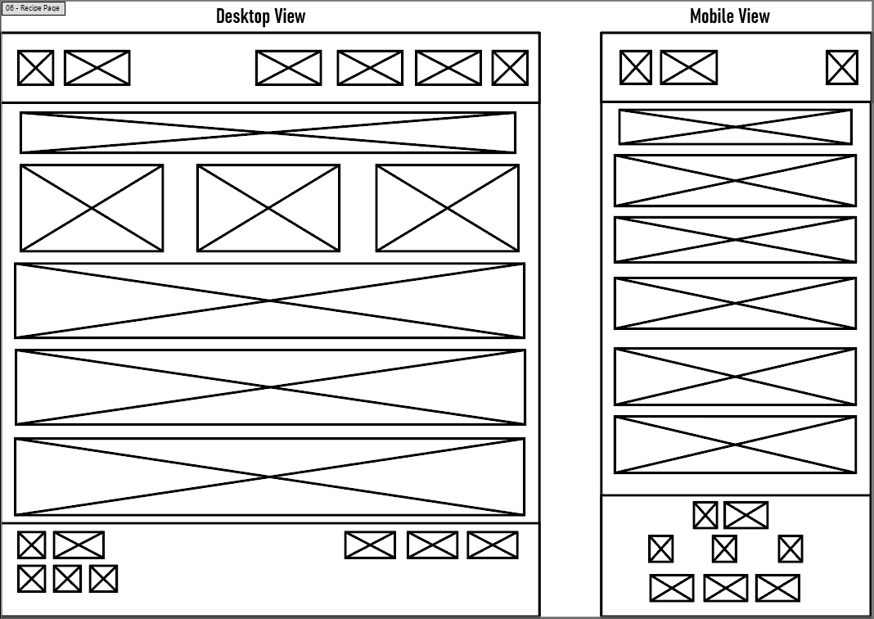

## Low Fidelity - Contact Page

## 

## 

# Logo Design

## Logo Design Draft Ideas

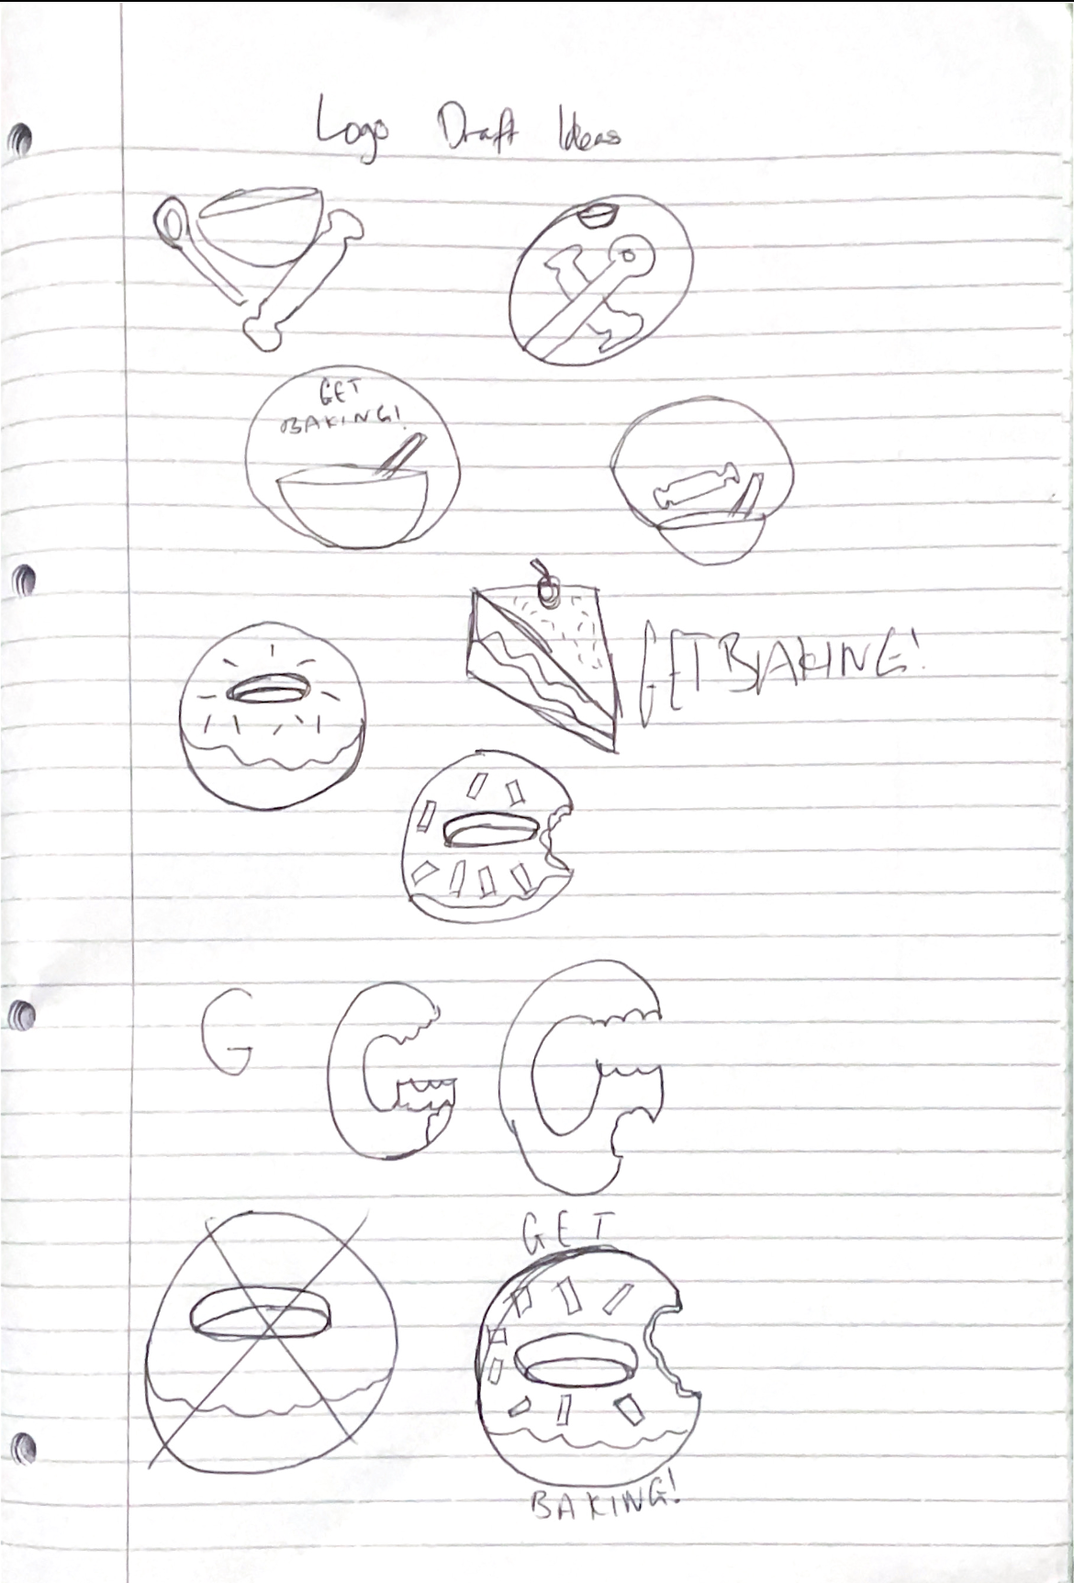

## Final Logo Designed in Illustrator

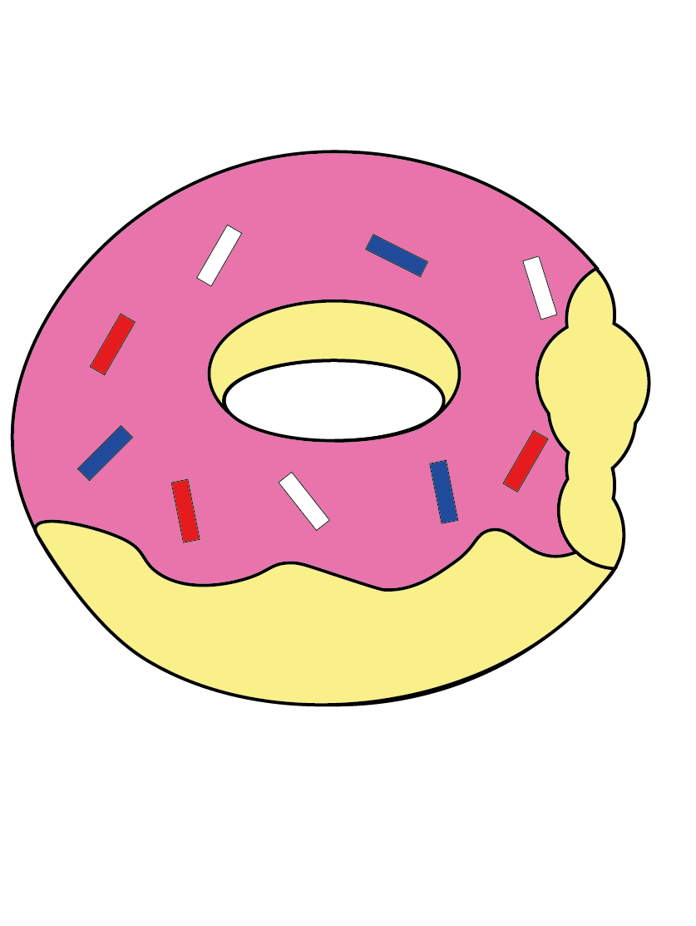

## Logo as a Favicon

## 

## Design as Favicon In Tab

## 

## 

## Design Ready to Made into a Progressive Web App with multiple Sizings and a Maskable Icon

## 

# Mid Fidelity

## Mid Fidelity - Overview

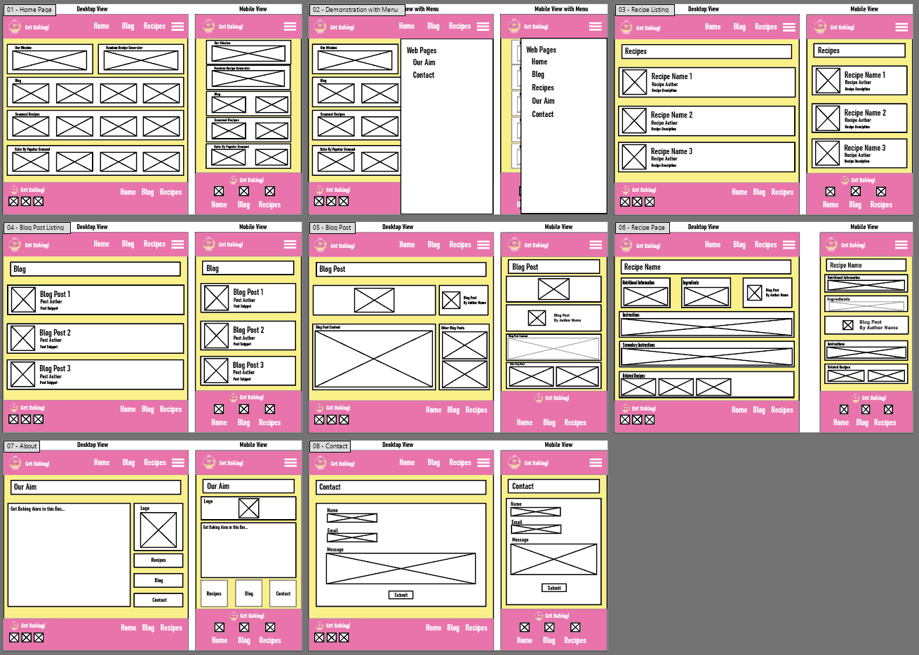

## Mid Fidelity - Home Page

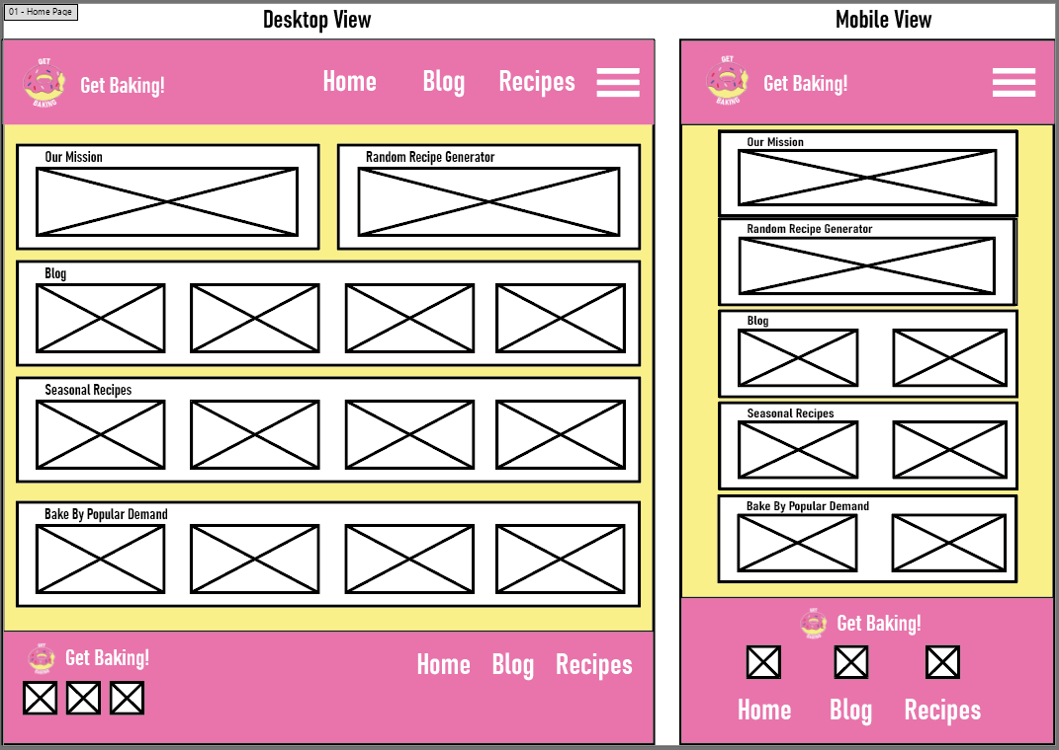

## Mid Fidelity - Mobile Menu Demonstration

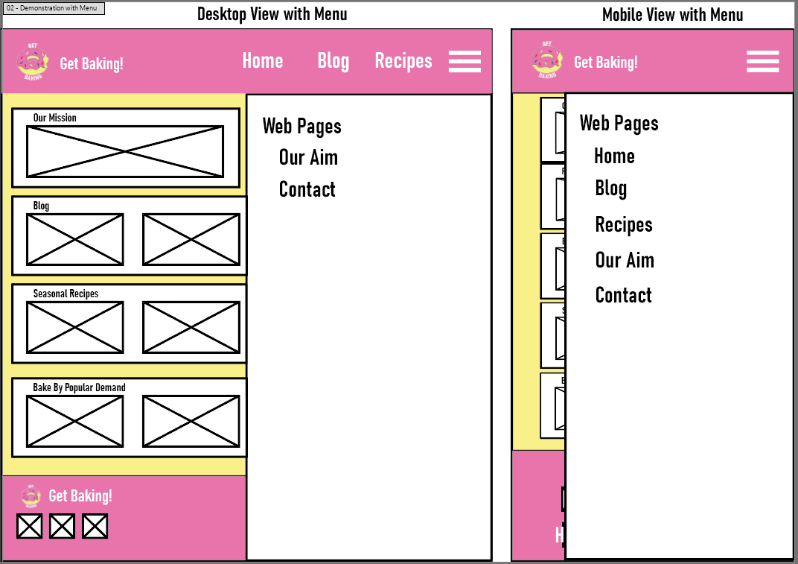

## Mid Fidelity - About Page

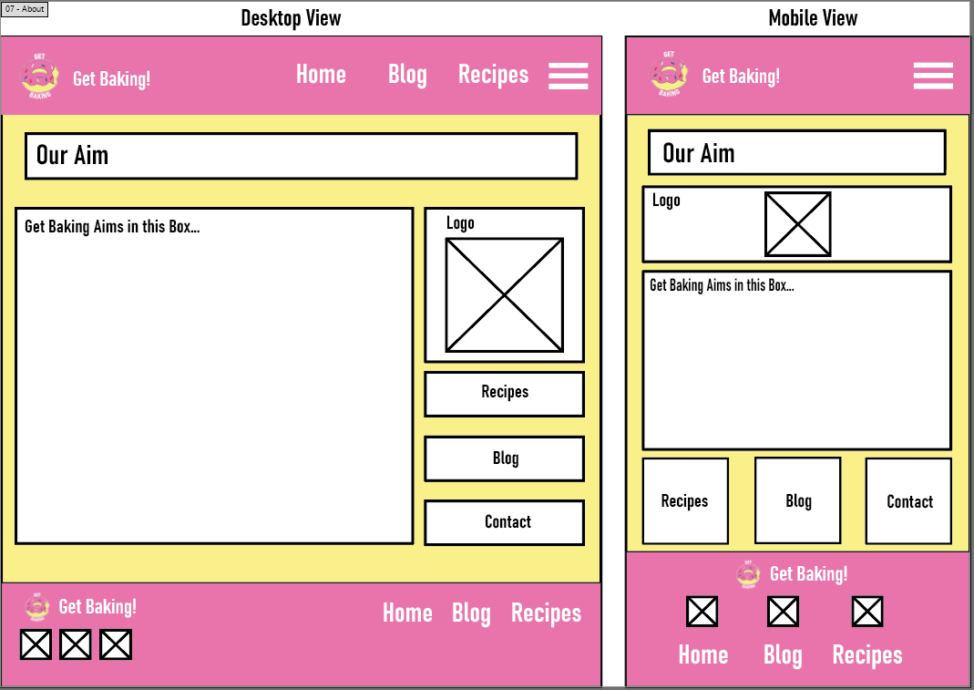

## Mid Fidelity - Blog Listing Page

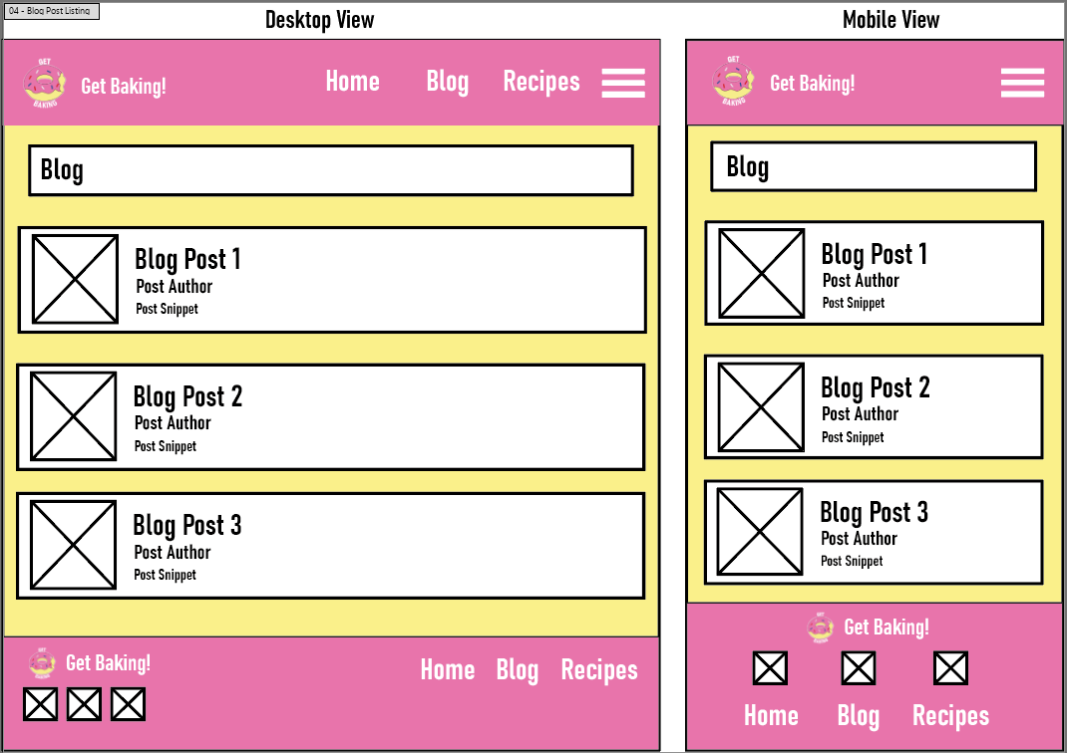

## Mid Fidelity - Blog Post Page

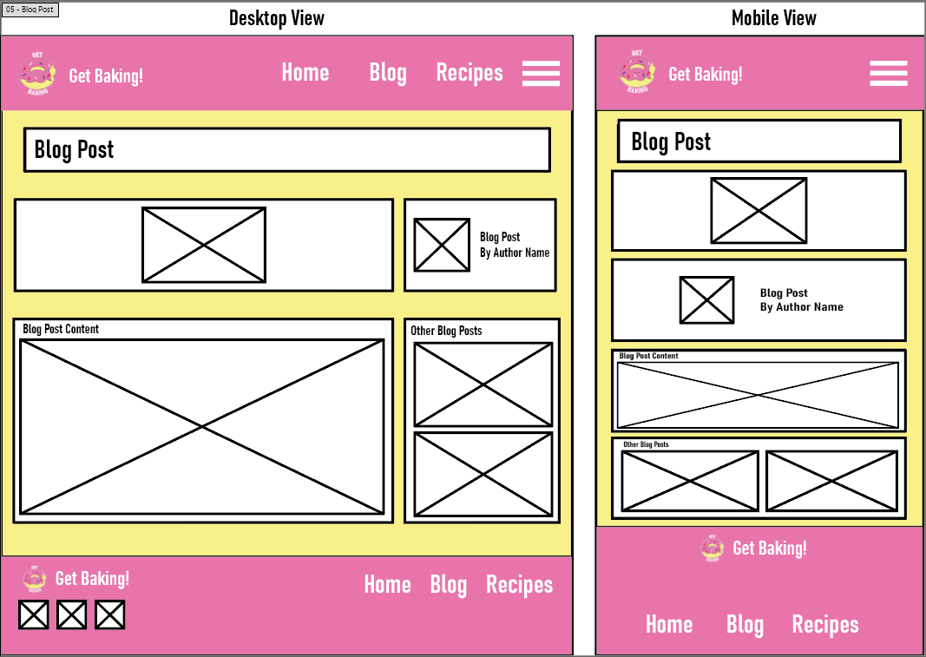

## Mid Fidelity - Recipe Listing Page

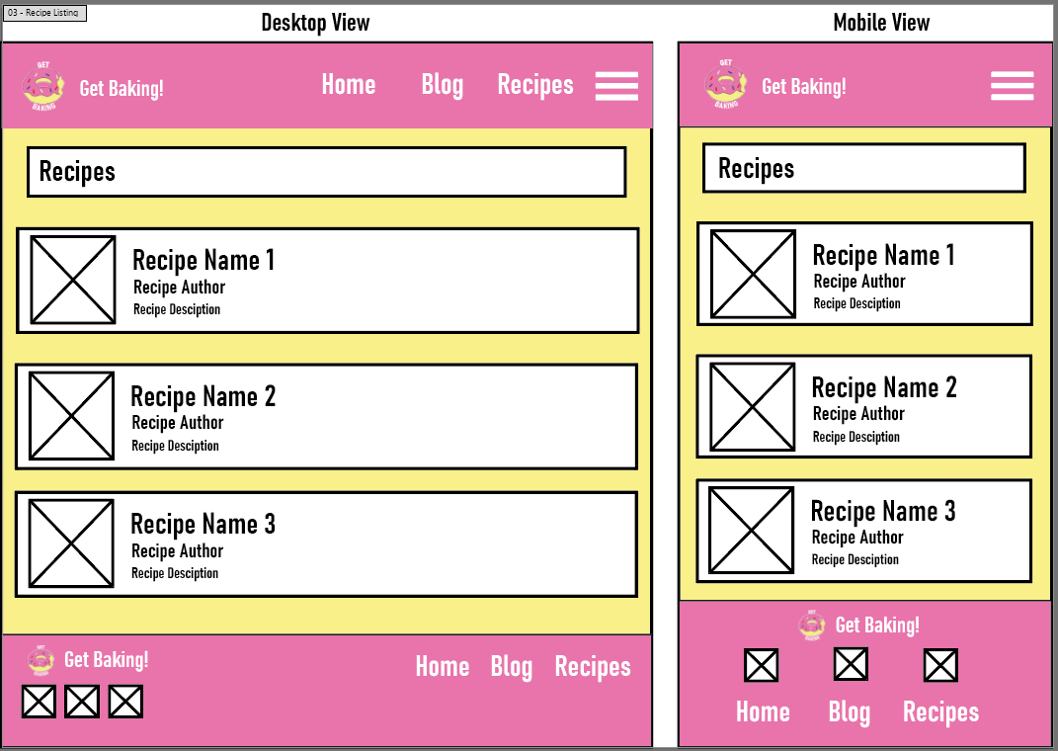

## Mid Fidelity - Recipe Page

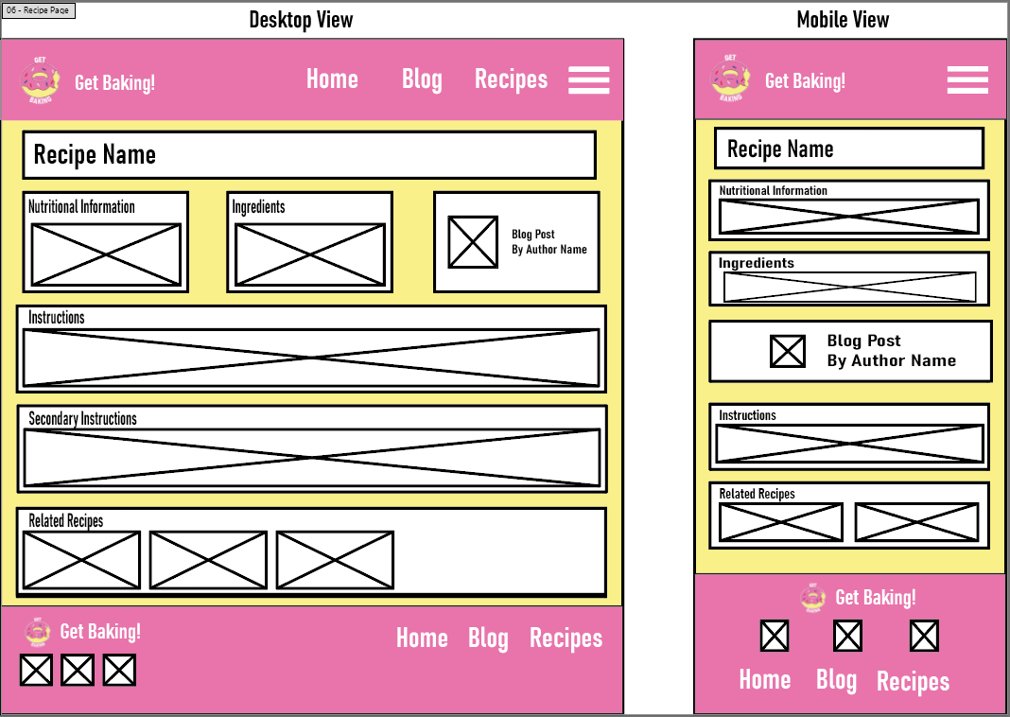

## Mid Fidelity - Contact Page

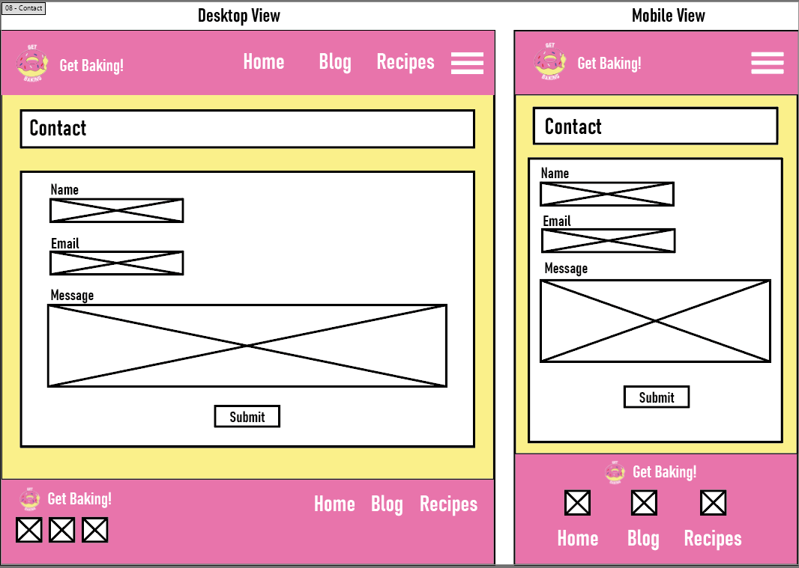

# Testing

## Get Baking Test Suite Overview

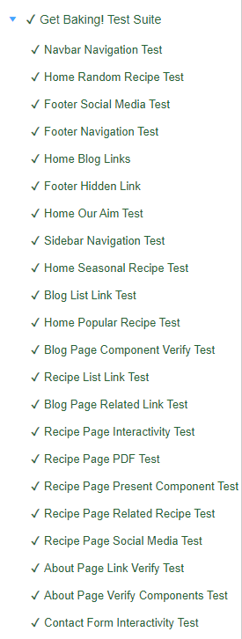

## Navbar Navigation Test

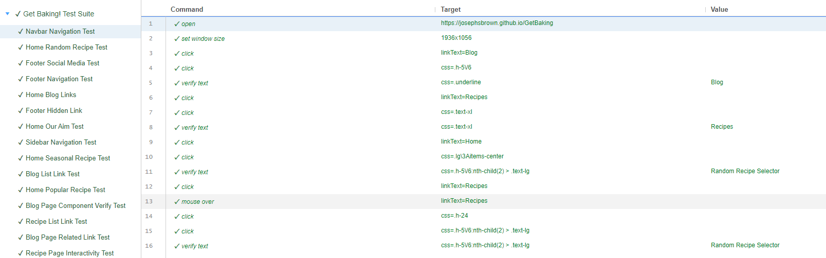

## Home Random Recipe Test

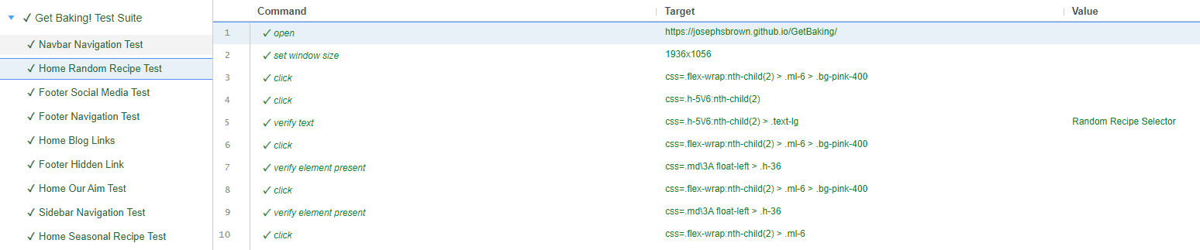

## Footer Social Media Test

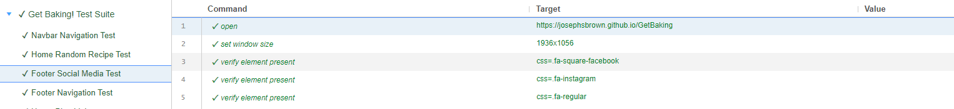

## Footer Navigation Test

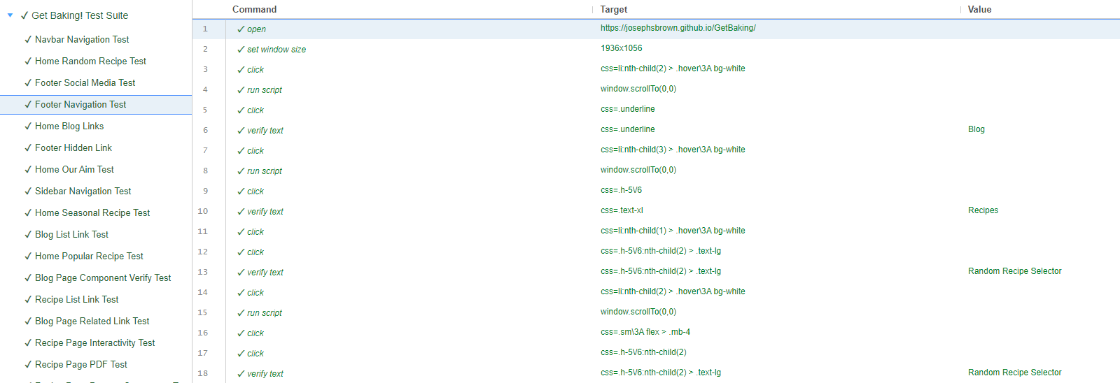

## Home Blog Links Test

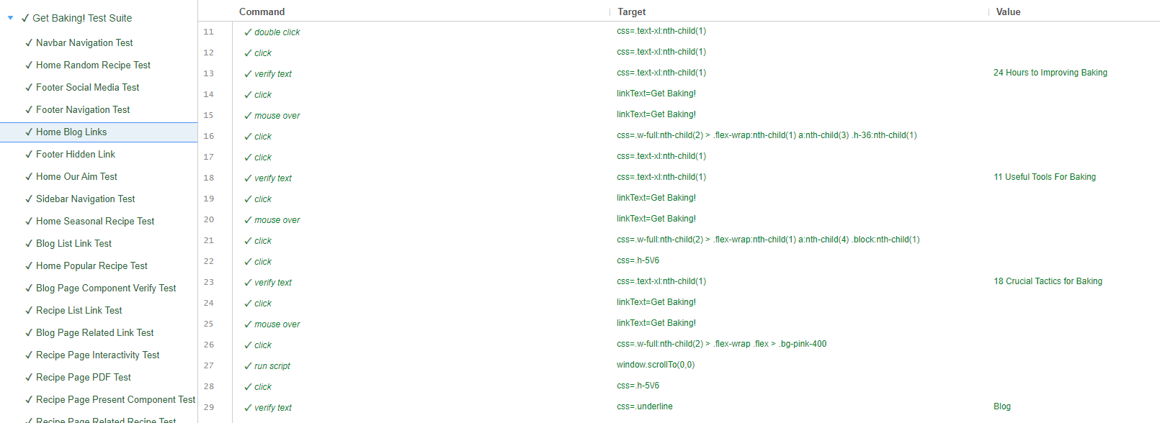

## Footer Hidden Link Test

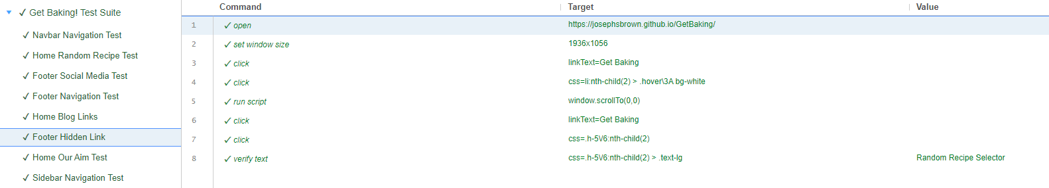

## Home Our Aim Test

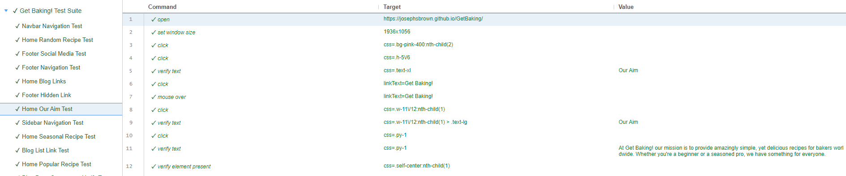

## Sidebar Navigation Test

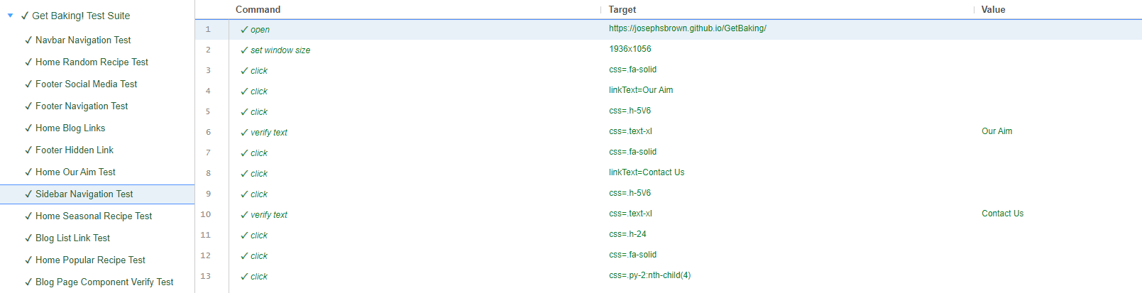

## Home Seasonal Recipe Test

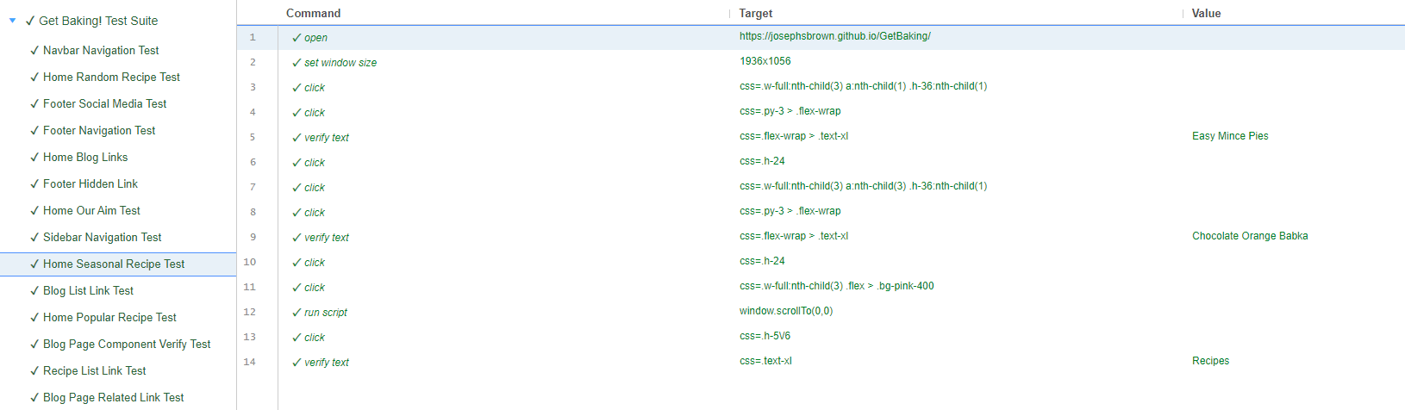

## Blog List Link Test

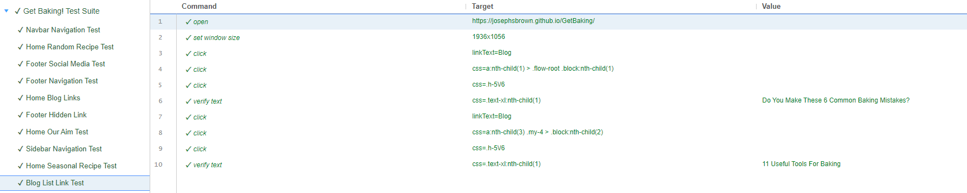

## Home Popular Recipe Test

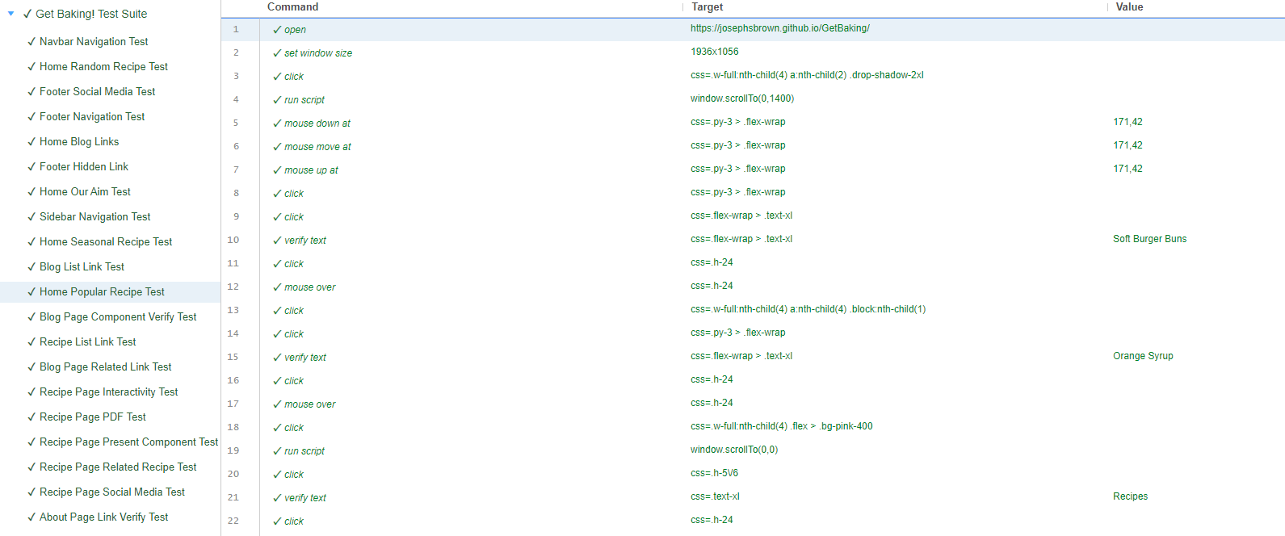

## Blog Page Component Verify Test

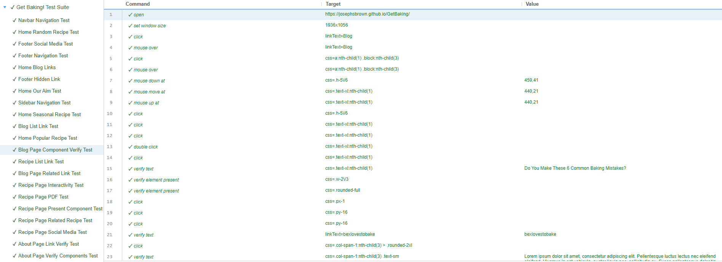

## Recipe List Link Test

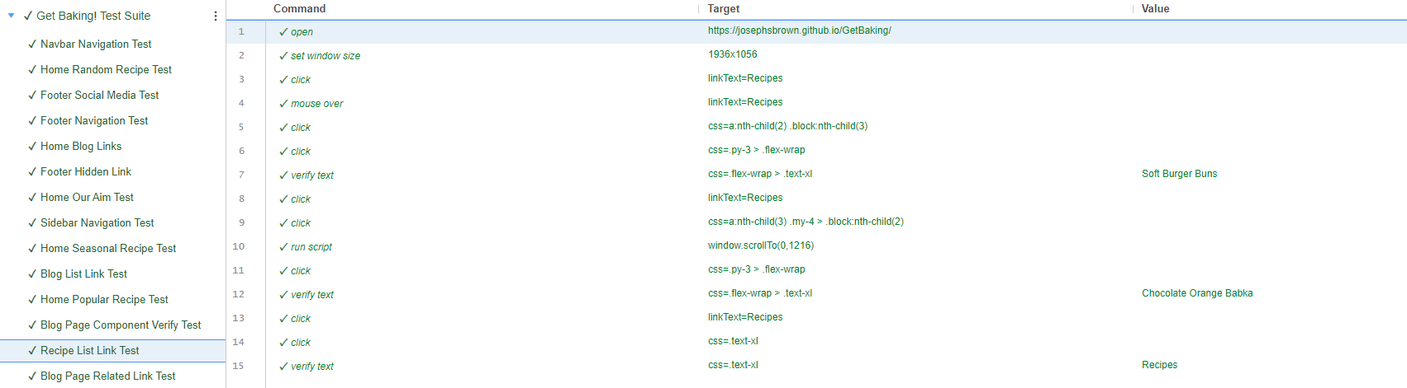

## Blog Page Related Link Test

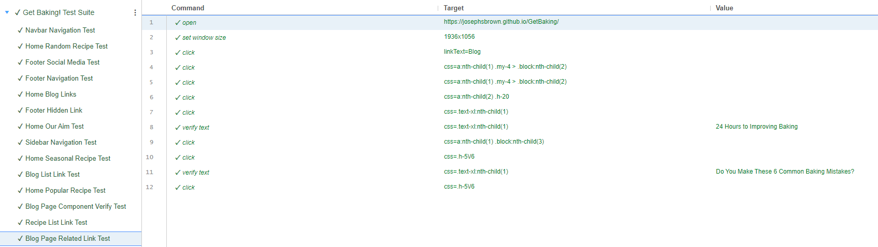

## Recipe Page Interactivity Test

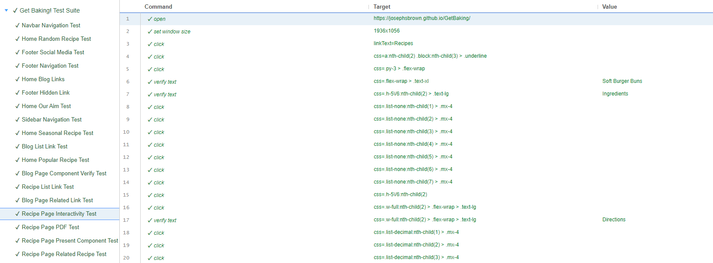

## Recipe Page PDF Test

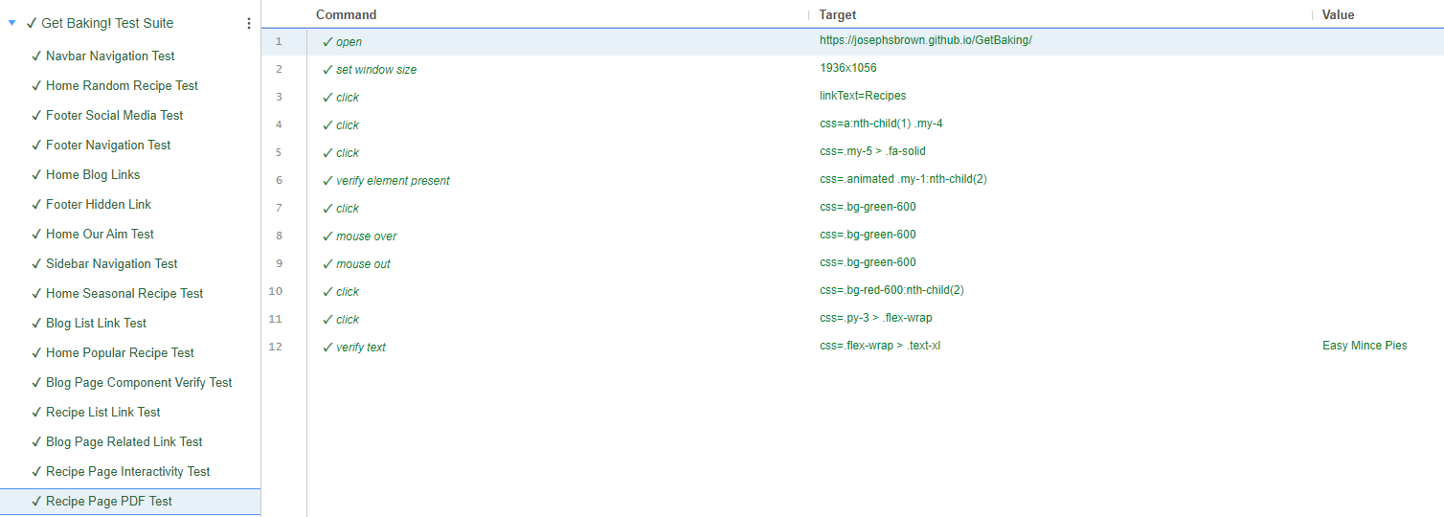

## Recipe Page Present Component Test

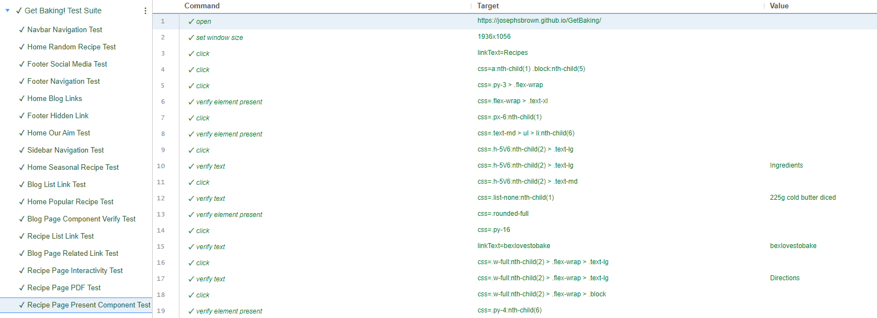

## Recipe Page Related Recipe Test

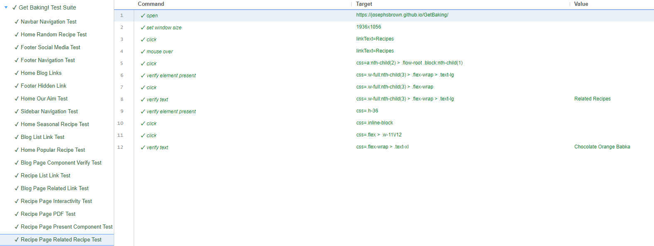

## Recipe Page Social Media Test

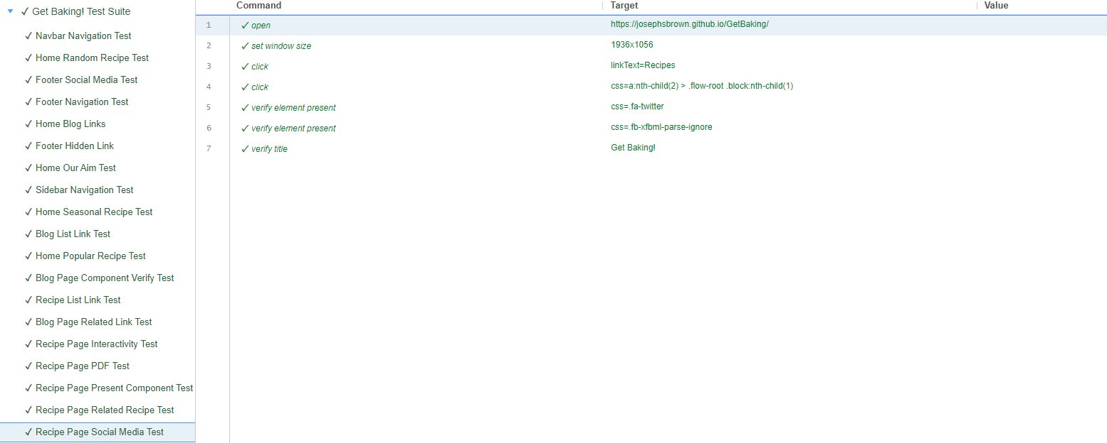

## About Page Link Verify Test

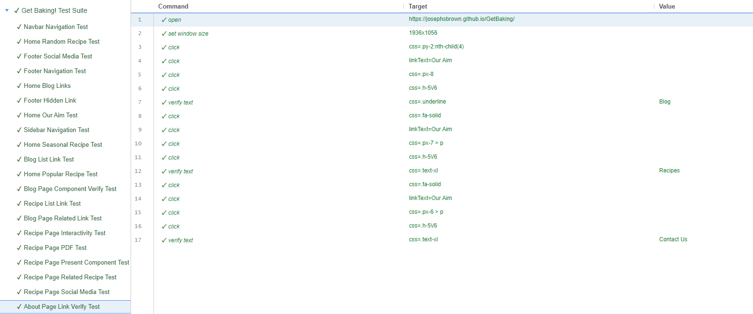

## About Page Verify Components Test

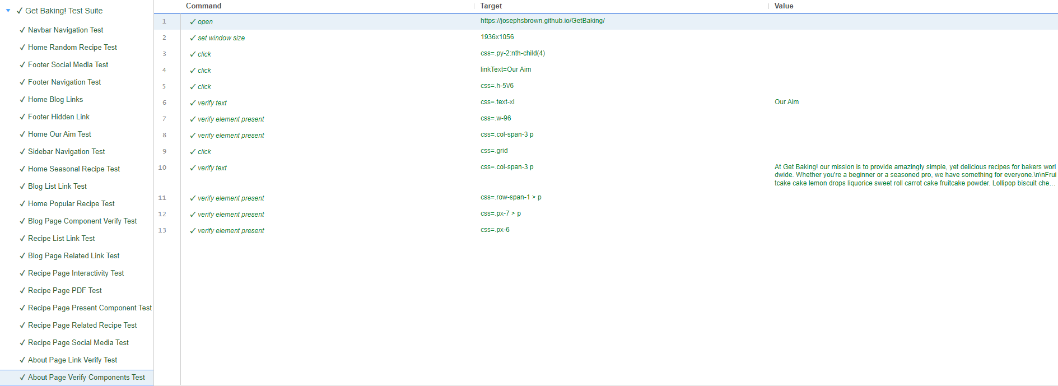

## Contact Form Interactivity Test

## 